|  |
| --- |
| Close-up image showing the leaf-sides of two oversized books side-by-side on a bookshelf, with additional books in soft focus background |
| Samakary Parmaga  Exam on level 3 |
| |  |  |  | | --- | --- | --- | | Write by: | Hamada Mahmoud Hamada | Basic python | |

Note: Before starting, the exam is 5 minutes long and has 10 questions. If the person closes all the questions, he will get a 50% discount. If he closes it after the appointed time, he will get a 25% discount. The entire exam is multiple-choice questions.

1. What is loop?
2. are fundamental concept in programming that allow you to repeat a block of code same time.
3. are fundamental concept in programming that allow you to repeat a block of code multiple times.
4. are fundamental concept in programming that allow you to execute a condition.
5. No thing
6. To create a list you must use____
7. ()
8. []
9. {}
10. <>
11. What is a method used to Add an element at the specified position __
12. Append
13. Pop
14. Remove
15. insert
16. What operation return true if a sequence with the specified value is present in the object?
17. Is
18. Is not
19. In
20. In not
21. What is the method used to stop the loop before it has looped through all the items?
22. Extend
23. Break
24. Continue
25. Index
26. What method is used to add a list within a list at the end of the list?
27. Extend
28. Pop
29. Continue
30. break
31. What is the process in which you put more than one loop?
32. Identity operator
33. Membership operator
34. Nested loop
35. Nested if
36. What operator is used to return true if the both variables are the same object?
37. Is
38. Is not
39. In
40. In not
41. Guess output:

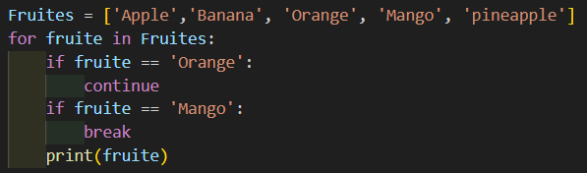

1. Apple, Banana, Orange
2. Apple, Banana
3. Apple, Banana, Mango
4. Apple, Banana, Pineapple
5. Guess output:

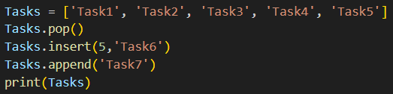

1. [Task1, Task2, Task3, Task4, Task6, Task7]
2. [Task2, Task3, Task6, Task7]
3. [Task6, Task1, Task2, Task3, Task4, Task7]
4. [Task7, Task1, Task2, Task3, Task4, Task6]

Finish The Exam